**CSCI E-79: The Art and Design of Information**

Zona Kostic-Barthelemy & Giulia Zerbini

Spring 2019

LAB 1

Drawing Data

# 

**Index:**

-- Introduction

01 / VISUAL THINKING FOR DATA EXPLORATION

02 / EXPLORING VISUAL MODELS

03 / SHAPING INFORMATION

04 / THE VISUALIZATION DRAFT

##### -- Credits and Additional Resources

# Introduction

Welcome to E-79 Lab 1!

*You are about to enter the world of design and information visualization. Labs will be there to help you mastering the core skills. They are structured as self-guided tutorials through the process of creating a visualization - from a concept definition to the final design. Following the sequential steps, this process will help you build a basic design skills that you can further improve with a time. The purpose of Labs is to provide you with practical artistry as well as the guidelines of how to acquire a creative method and produce the final project of the course. The examples we will be using consider practices of visual thinking, sketching by hand, creating visualizations with tool, drawing and editing with Illustrator and designing editorials and digital visualizations.*

Note: All sketches in this Lab are hand drawn.

### Topics and Learning Objectives

Lab 1 focuses on reading data and coming up with the visualization draft using only pen and paper. This is the first step in the process of creating a meaningful and effective visualization.

When working on a visualization, you should always keep in mind that:

# “graphics reveal data”

quoting one of the most important Tufte’s[1] principles.

A good visualization is able to communicate data with clarity, precision and efficiency and goes beyond the simple display of information. It requires a deep understanding of the data and a meticulously study on the most effective way to communicate the information.

Design process is very unique and it is subject to an idea and concept. But there are some good practices that can help you structuring your first approach to the visualization and information design.

#### The topics and learning objectives that will be covered:

* Visual thinking with data
* Sketch variables and insights in data
* Learn how to sketch different types of visual models
* Learn how to combine and customize visual models
* Design a coherent and effective design architecture
* Experiment with visual combinations
* Communicate a specific trend efficiently

## 

## Figure 1: Topics, learning objectives, and exercises

## 01 /

# Visual thinking for data exploration

### WHAT IS VISUAL THINKING?

Visual thinking is a way to increase your understanding, organize your thoughts, and communicate your messages clearly. The core of visual thinking is drawing, but not everyone is comfortable with it.

There are few reasons why most people are less comfortable with drawing. First, there is a myth that you have to be born as an artist, with developed and expressive style in order to have a successful career. There might be 1 out of 6 people with being born with an artistic gene. Everyone else can work on their drawing skills and be able to perfect them with a time.

Another reason people run away from sketching is some sort of “creative laziness”. The work environment has provided a vast amount of tools (e.g. Power Point, Excel… etc.) with a predefined charts library. These presets are completed visual forms that limit our visual thinking and visual vocabulary. Rather than thinking about potential visual clues, many people emphasise the chart libraries, constraining themselves to what is available in the gallery.

Visual thinking is crucial technique to be developed for working with data. It helps communicate ideas clearly and helps reaching higher-level understanding of visually less obvious patterns.

Figure 2: The role of visualization in data analysis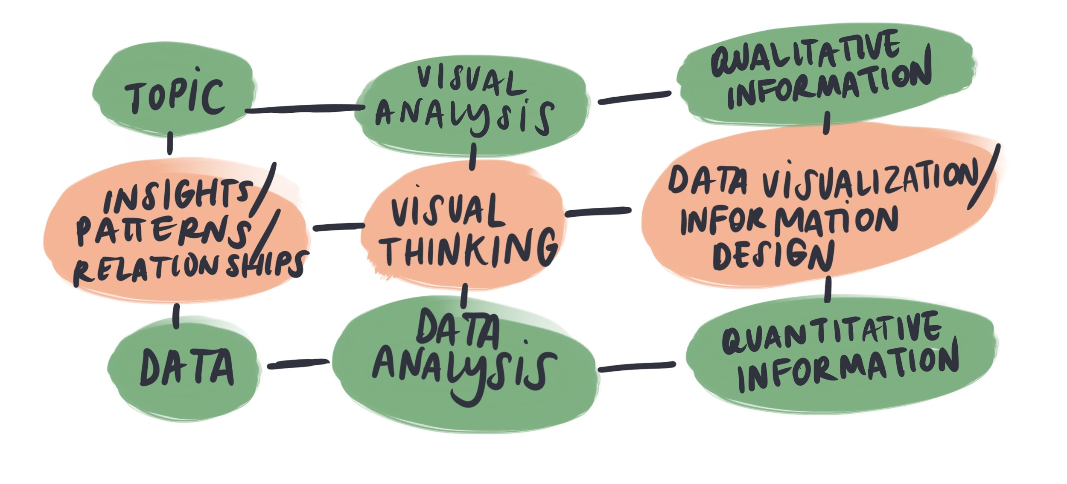

### WHAT IS FUNCTIONAL DRAWING?

Functional drawing is not about visually pleasing sketches or unique brand identity. Functional drawing helps:

1. increasing the number of ideas
2. improving the speed to which you create prototypes
3. increasing your understanding of a concepts by exploring it in different ways (e.g. observing the same topic from different perspectives)
4. promoting the ability to communicate (using words sometimes your idea cannot be understandable - using visuals combined with words is easier to grasp)

### Exercise 1

## HOW TO SKETCH DATA

Mastering sketching considers these two activities: learn how to control your hand and learn how to observe the elements around your. In this section, we will cover two exercises that will teach you the basics of sketching, how to practise your hand as well as how to “read” the data.

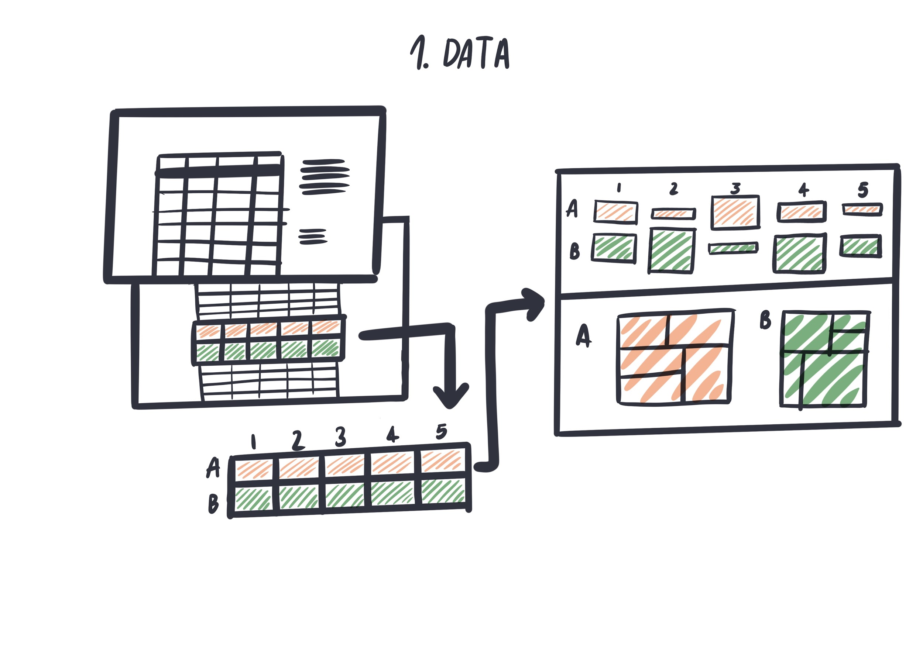

Figure 3: From a spreadsheet to a visual conclusion

###### Distribute circles of various size on a piece of paper until the paper is filled.

###### Make sure the circles do not overlap.

##### Drawing circles is not as easy as you might think. Notice how circles become harder, the bigger you make them. Try in both directions , making as many circles as possible.

[](https://drive.google.com/open?id=10H-WYGE41cWY1v6hkrr0meATUiq9Wg4J)

Figure 4: Drawing circles on a piece of paper

*Click on the picture to see animation*

###### *Fill a piece of paper with parallel lines*.

##### Diagonal lines come easy for us because they comply to the motion of our wrist. Try to follow the example shown with Figure 5. Make sure to try different directions as well. Combine various hatchings and enjoy watching the darkness spread on your paper. *Do not rotate the paper!* The whole point here is to train your hand to get comfortable with all directions. Have fun!

[](https://drive.google.com/open?id=1f4XfDi4XxKjnFqR_wlwVYFRvQ1BkLOj_)

Figure 5: Drawing parallel lines on a piece of paper

*Click on the picture to see animation*

###### Take a look at Figure 6. Draw charts using pen and paper.

###### Make sure to maintain the right proportions between the elements.

Below graphs represent the same data in different visual forms. In this exercise we want to focus on representing different shapes, trying to maintain proportions between the elements, and copy basic visual models.

##### Points scoredPoints scored

Figure 6: Example of points scored from 4 teams

in different periods of time

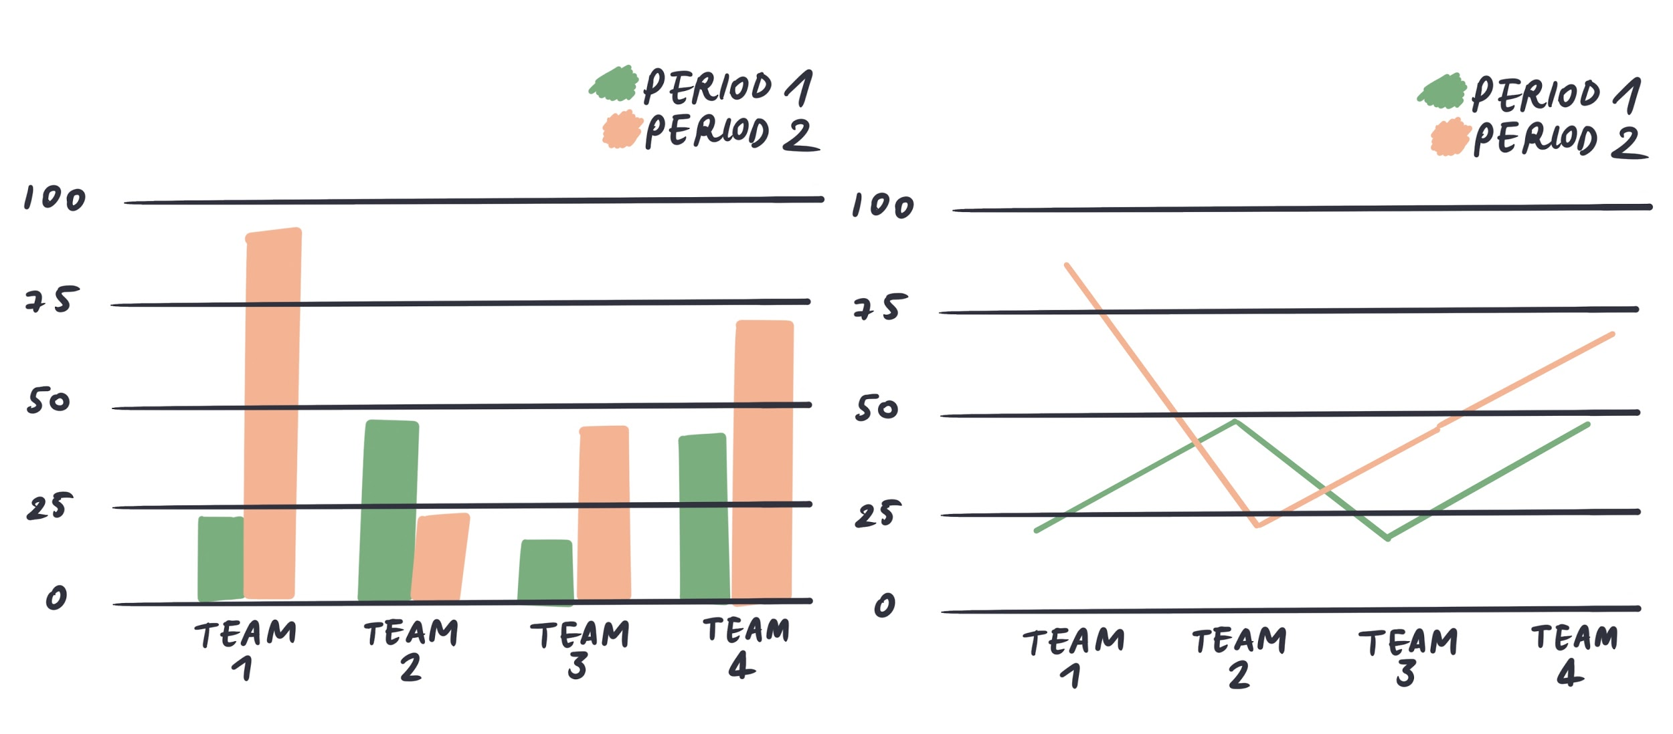Figure 7: Examples of hand sketched barchart and line chart

###### Choose any 2 visual models (except barchart and line chart) to represent the data.

##### Familiarize yourself with visual models. Explore this library:

##### <https://datavizproject.com>

##### Choose visual representations that could draw the insights of your data. Sketch them. The purpose of this exercise is to gain practice with the visual analysis and data representation, using hand drawing and the different visual variables.

Remember that your visualizations don’t have to be mathematically precise. The important for you is to practice sketching and being able to recognize different types of visualization.

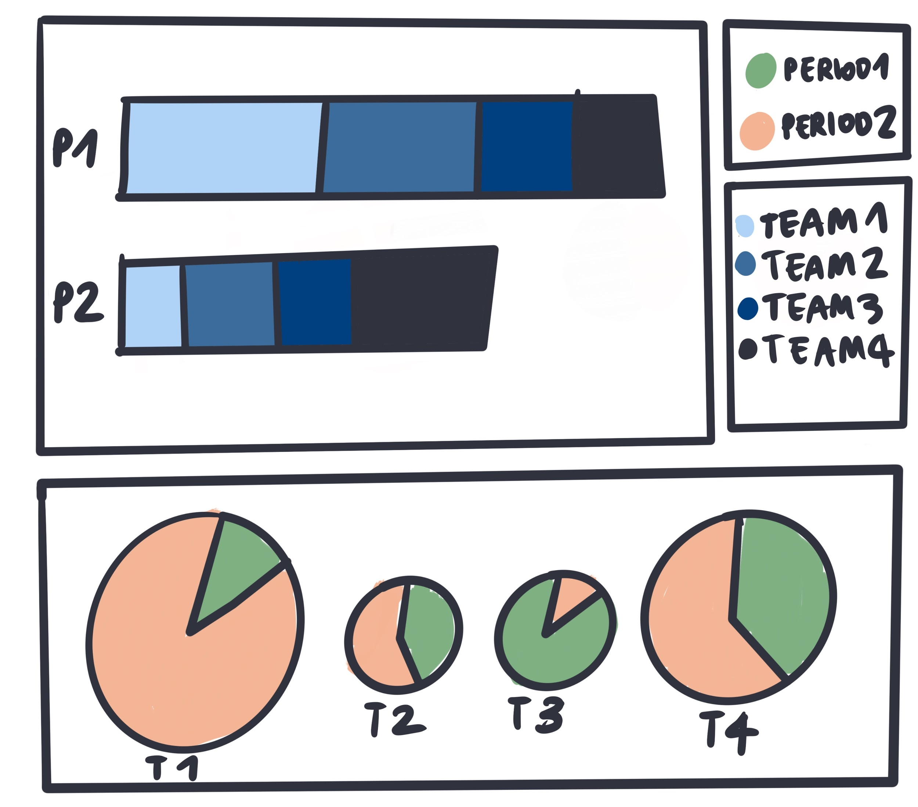

Figure 8: Visual Dashboard

## 02 /

# Exploring visual models

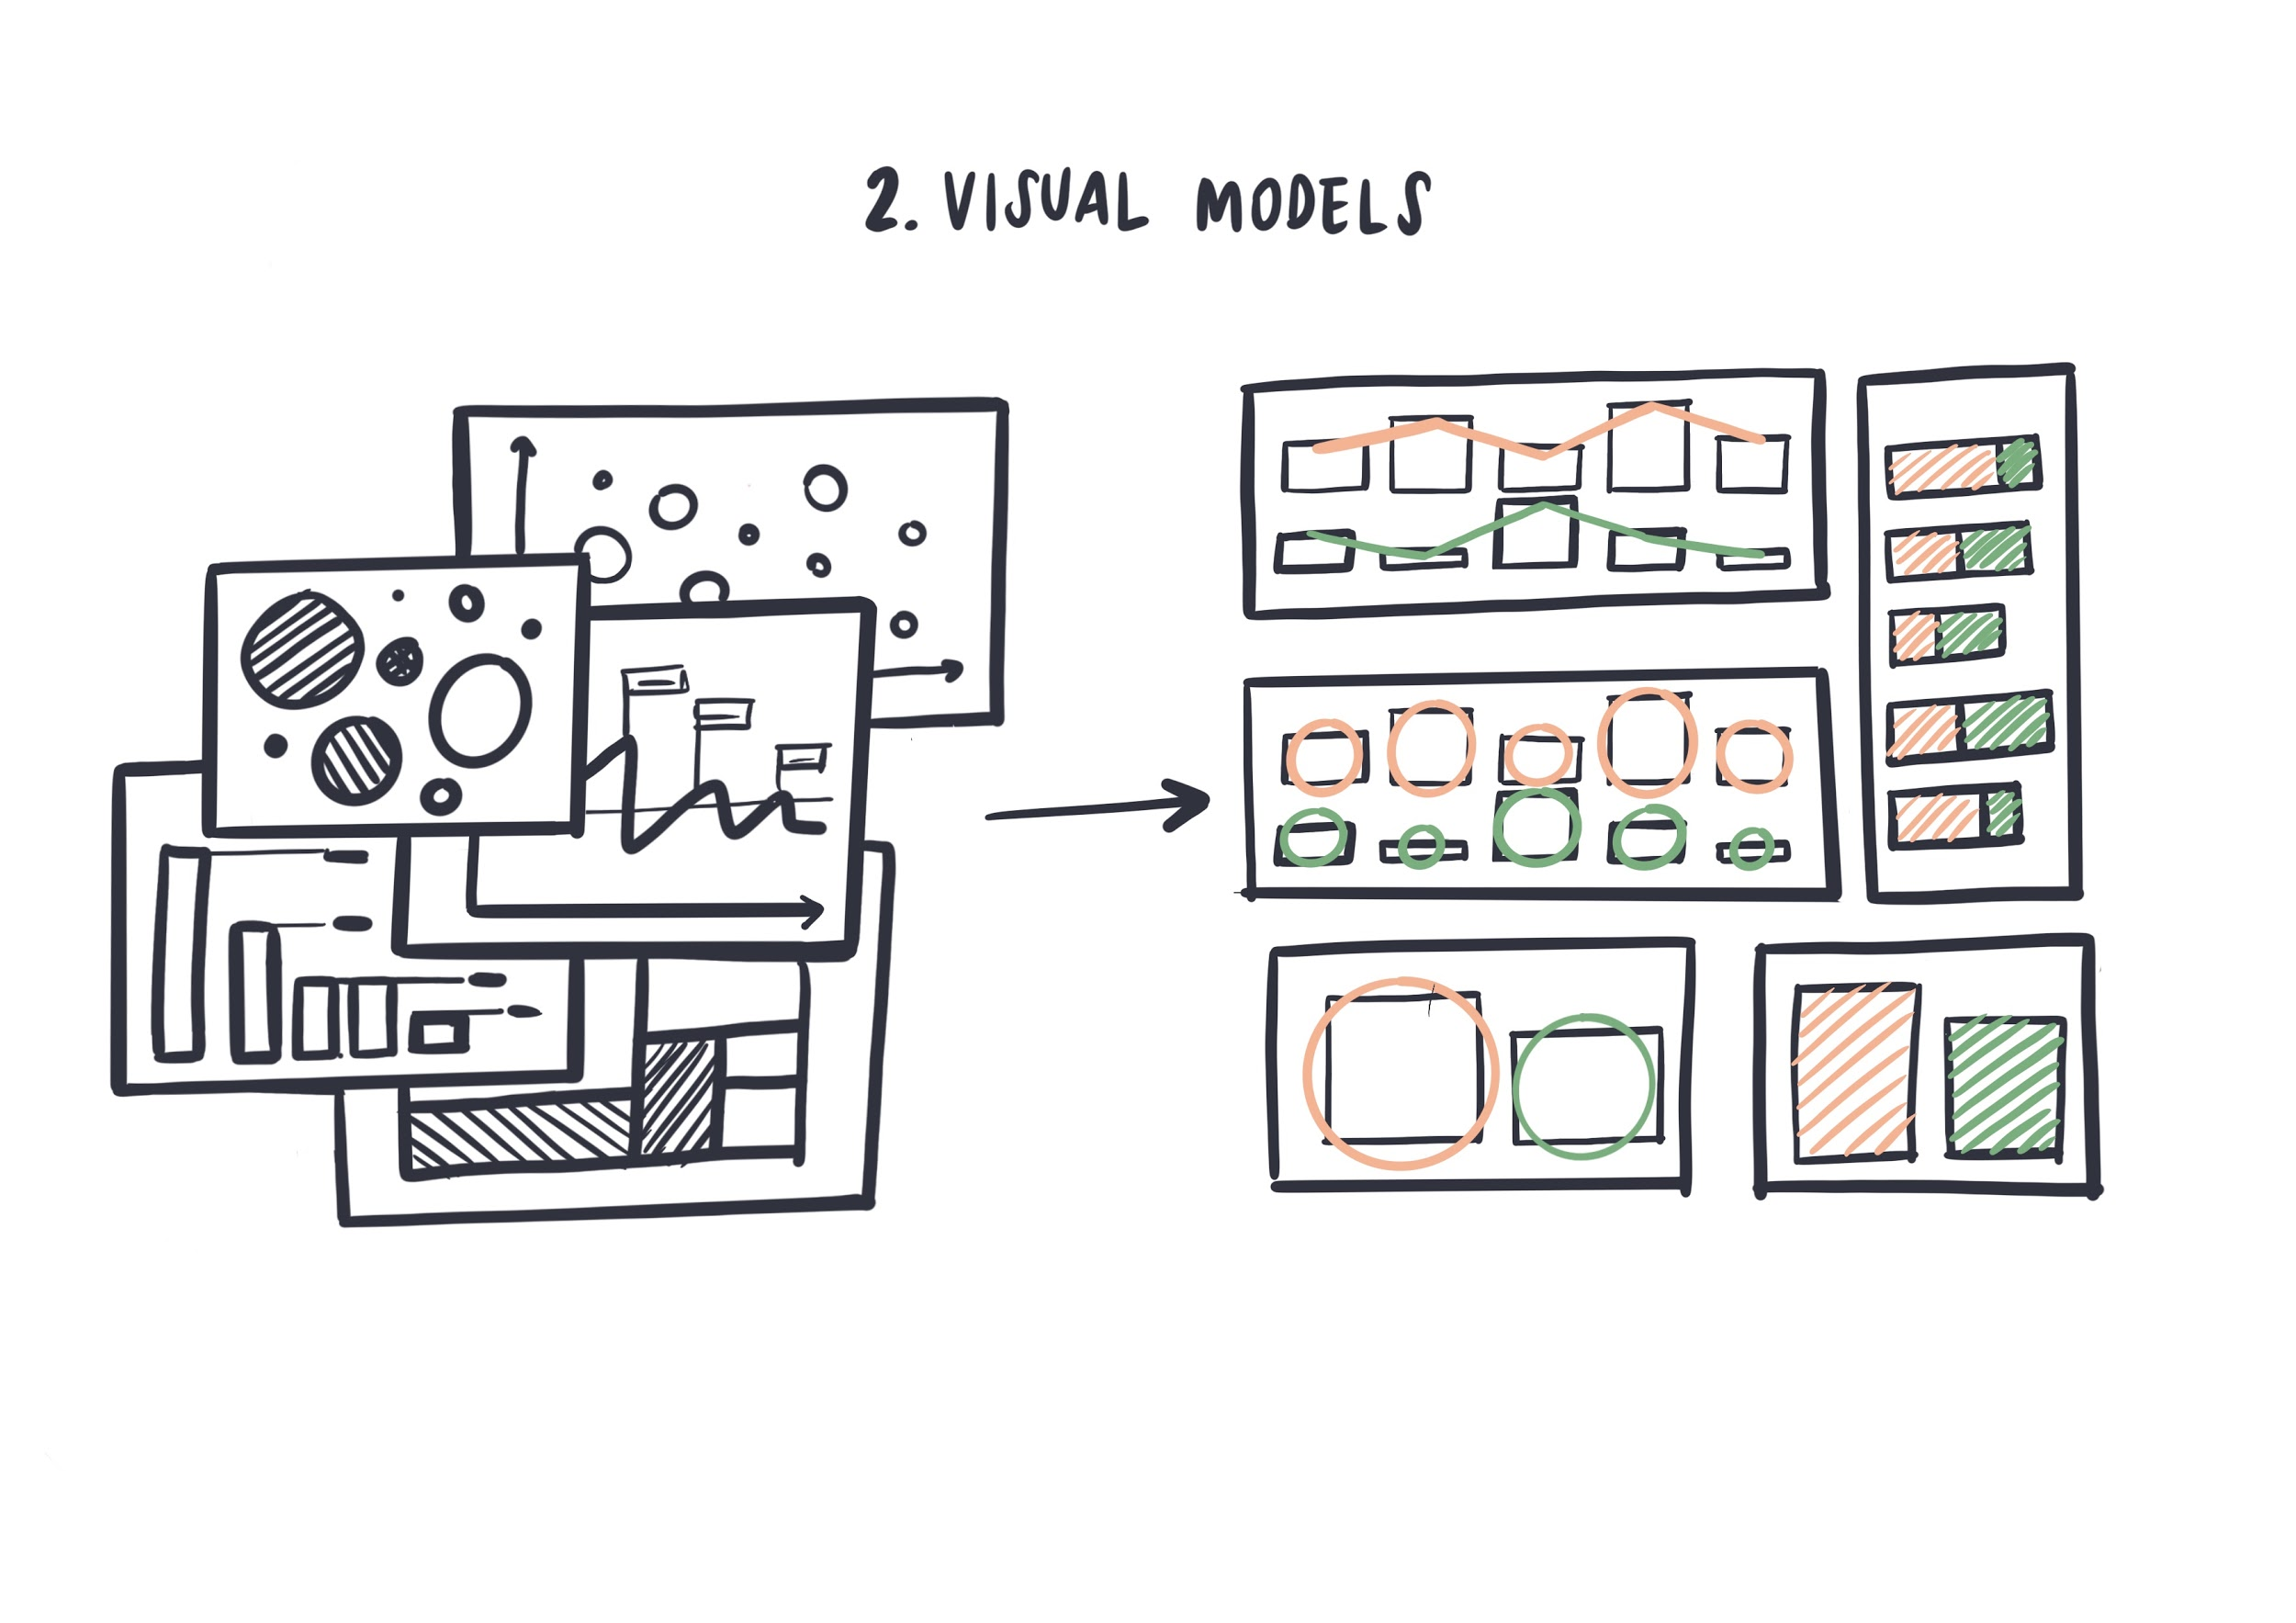

Figure 9: Visual Models

### 

### Exercise 2

**VISUALIZE YOUR DATA**

This section focuses on reading and analysing data, identifying data variables and insights in data. In this section, we are going to answer the question:

What do I want to communicate?

Try to sketch during each step of this process, draw or schematize what data tells you. Look for the insights or visual suggestions that data communicates. Visual thinking is a powerful tool to elaborate ideas and build graphic compositions. Sketches should be able to represent and communicate your thoughts and your cognitive processes. Do not put too much time in trying to prettify them.

###### 

###### Read your data.

## Who eats the food we grow?

##### Food production by country from 2004 to 2012.

Unit: 1 = 1000 tons

|  |  |  |  |  |  |
| --- | --- | --- | --- | --- | --- |
| **Area** | **2004** | **2006** | **2008** | **2012** | **TOTAL** |
| China | 2308836 | 2378139 | 2454912 | 2499252 | 22090365 |
| India | 1139043 | 1175435 | 1200891 | 1238335 | 10774362 |
| USA | 628586 | 625116 | 643044 | 641776 | 6327371 |
| Brazil | 313681 | 327899 | 315024 | 312488 | 2925111 |
| Russia | 251155 | 254777 | 256646 | 253892 | 2491508 |
| Indonesia | 220224 | 231674 | 239477 | 237826 | 2132813 |
| Nigeria | 208392 | 218174 | 221458 | 228877 | 2013681 |
| Pakistan | 170585 | 175339 | 178660 | 180994 | 1668153 |

##### 

##### 

##### This dataset is expressed through numerical values in the table, using one of the best ways to structure quantitative information. But there is way more than structures in this dataset. There are also relations that cannot be seen this way. Moreover, there are insights that lie between numbers and lines - patterns and structures that could be revealed with visualization.

A data visualization is

an abstraction of these

patterns and relationships.

###### Sketch insights in data using drawings, schemas, and charts.

What do the data communicate to you? Try to focus on patterns or trends that you see in the data, and sketch them in the form of a visual message. This step is fundamental to focus on the core of the visualization, to communicate the power of your data.

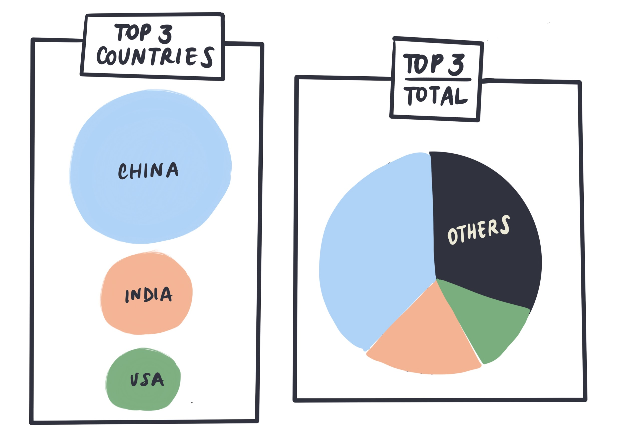

Figure 10: Effective communication - Bubble chart vs. Pie Chart

Look at the Figure 10. Is there something particularly interesting the author wants to communicate? In this case, the author tries to emphasize the importance of the biggest food producer and how this amount compares to other countries. The first three countries share more than 60% of the total production. Look at the Figure 10 again and try to visually observe these proportions.

After deciding on what’s the message you want to communicate, you can start thinking of other contextual information that would verify the correctness of your data. Using the above example, the author would like to compare its findings with the population in different countries, in order to prove the pattern and provide a meaningful context.

*Finding new data and explore visual models.*

If you are not happy with the amount of data you have, you can look for other datasets. The new dataset should align with yours, completing some missingnes or providing more in-depth information. A good resource for data is **Kaggle** where you can download open datasets:

<https://www.kaggle.com/>

Another step is to explore visual models, search for use-cases, references, visual inspirations, other projects. Find visual models that fit your data variables and that can represent found insights meaningfully. A good source for visual inspirations are **Pinterest** and **Behance**. Find projects that you like to see how different visual models can be combined and assembled to create visualizations. A good practice is to create a collections of works that inspires you catalogued by topic (es. use of colors, editorial visualizations, data experience) and keep them as a good resource for your future projects.

*Visualize your data using different visual models*

Once you have defined your dataset and explored different types of visual models you can start sketching your data.

In this part of the process the most important point is to focus on the representation of relationships, trends, patterns and finding the best way to communicate your “message”. It’s not crucial to make your visualizations mathematically precise. It is more important to communicate your findings clearly and truthfully.

Visualize your data by hand using different visual models, create a collections of sketches. The more you experiment, the faster you will understand the informative power of your visuals.

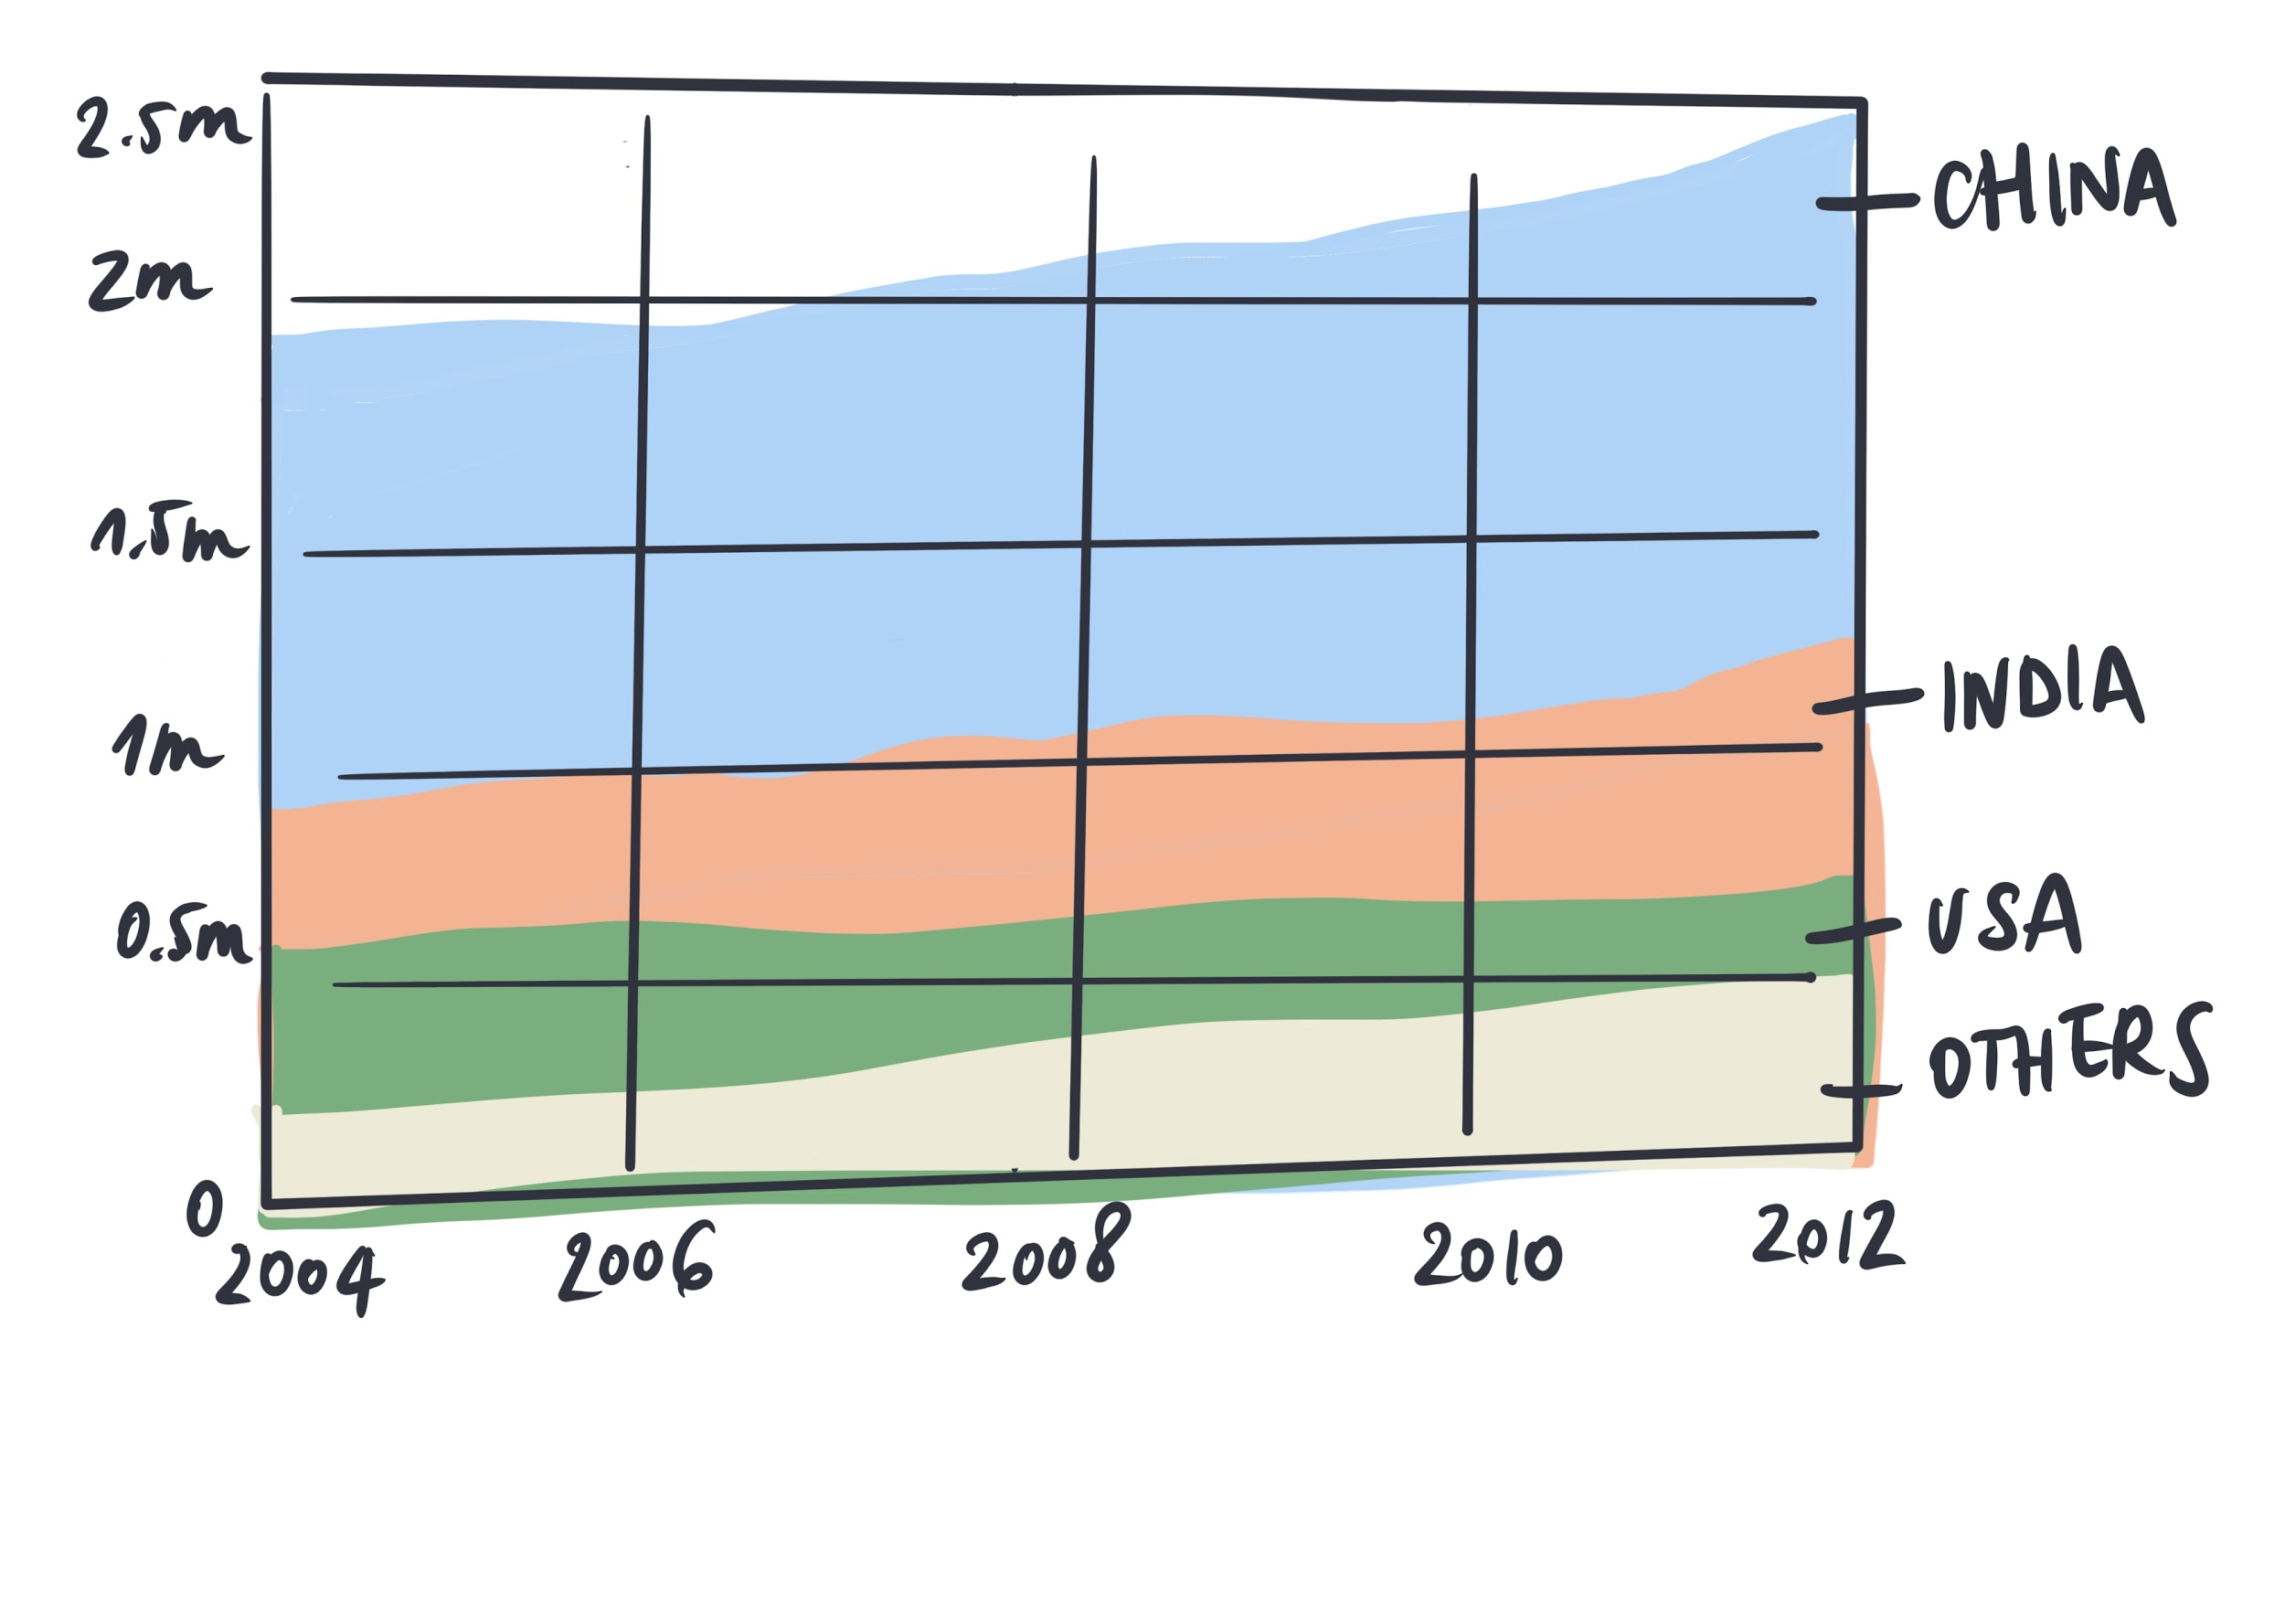

Figure 11: Area Chart

You don’t have to merge two datasets at this moment, but keep in mind that if you want to make a combined visual structure, you will have to use *the same visual representations and the correct proportions*.

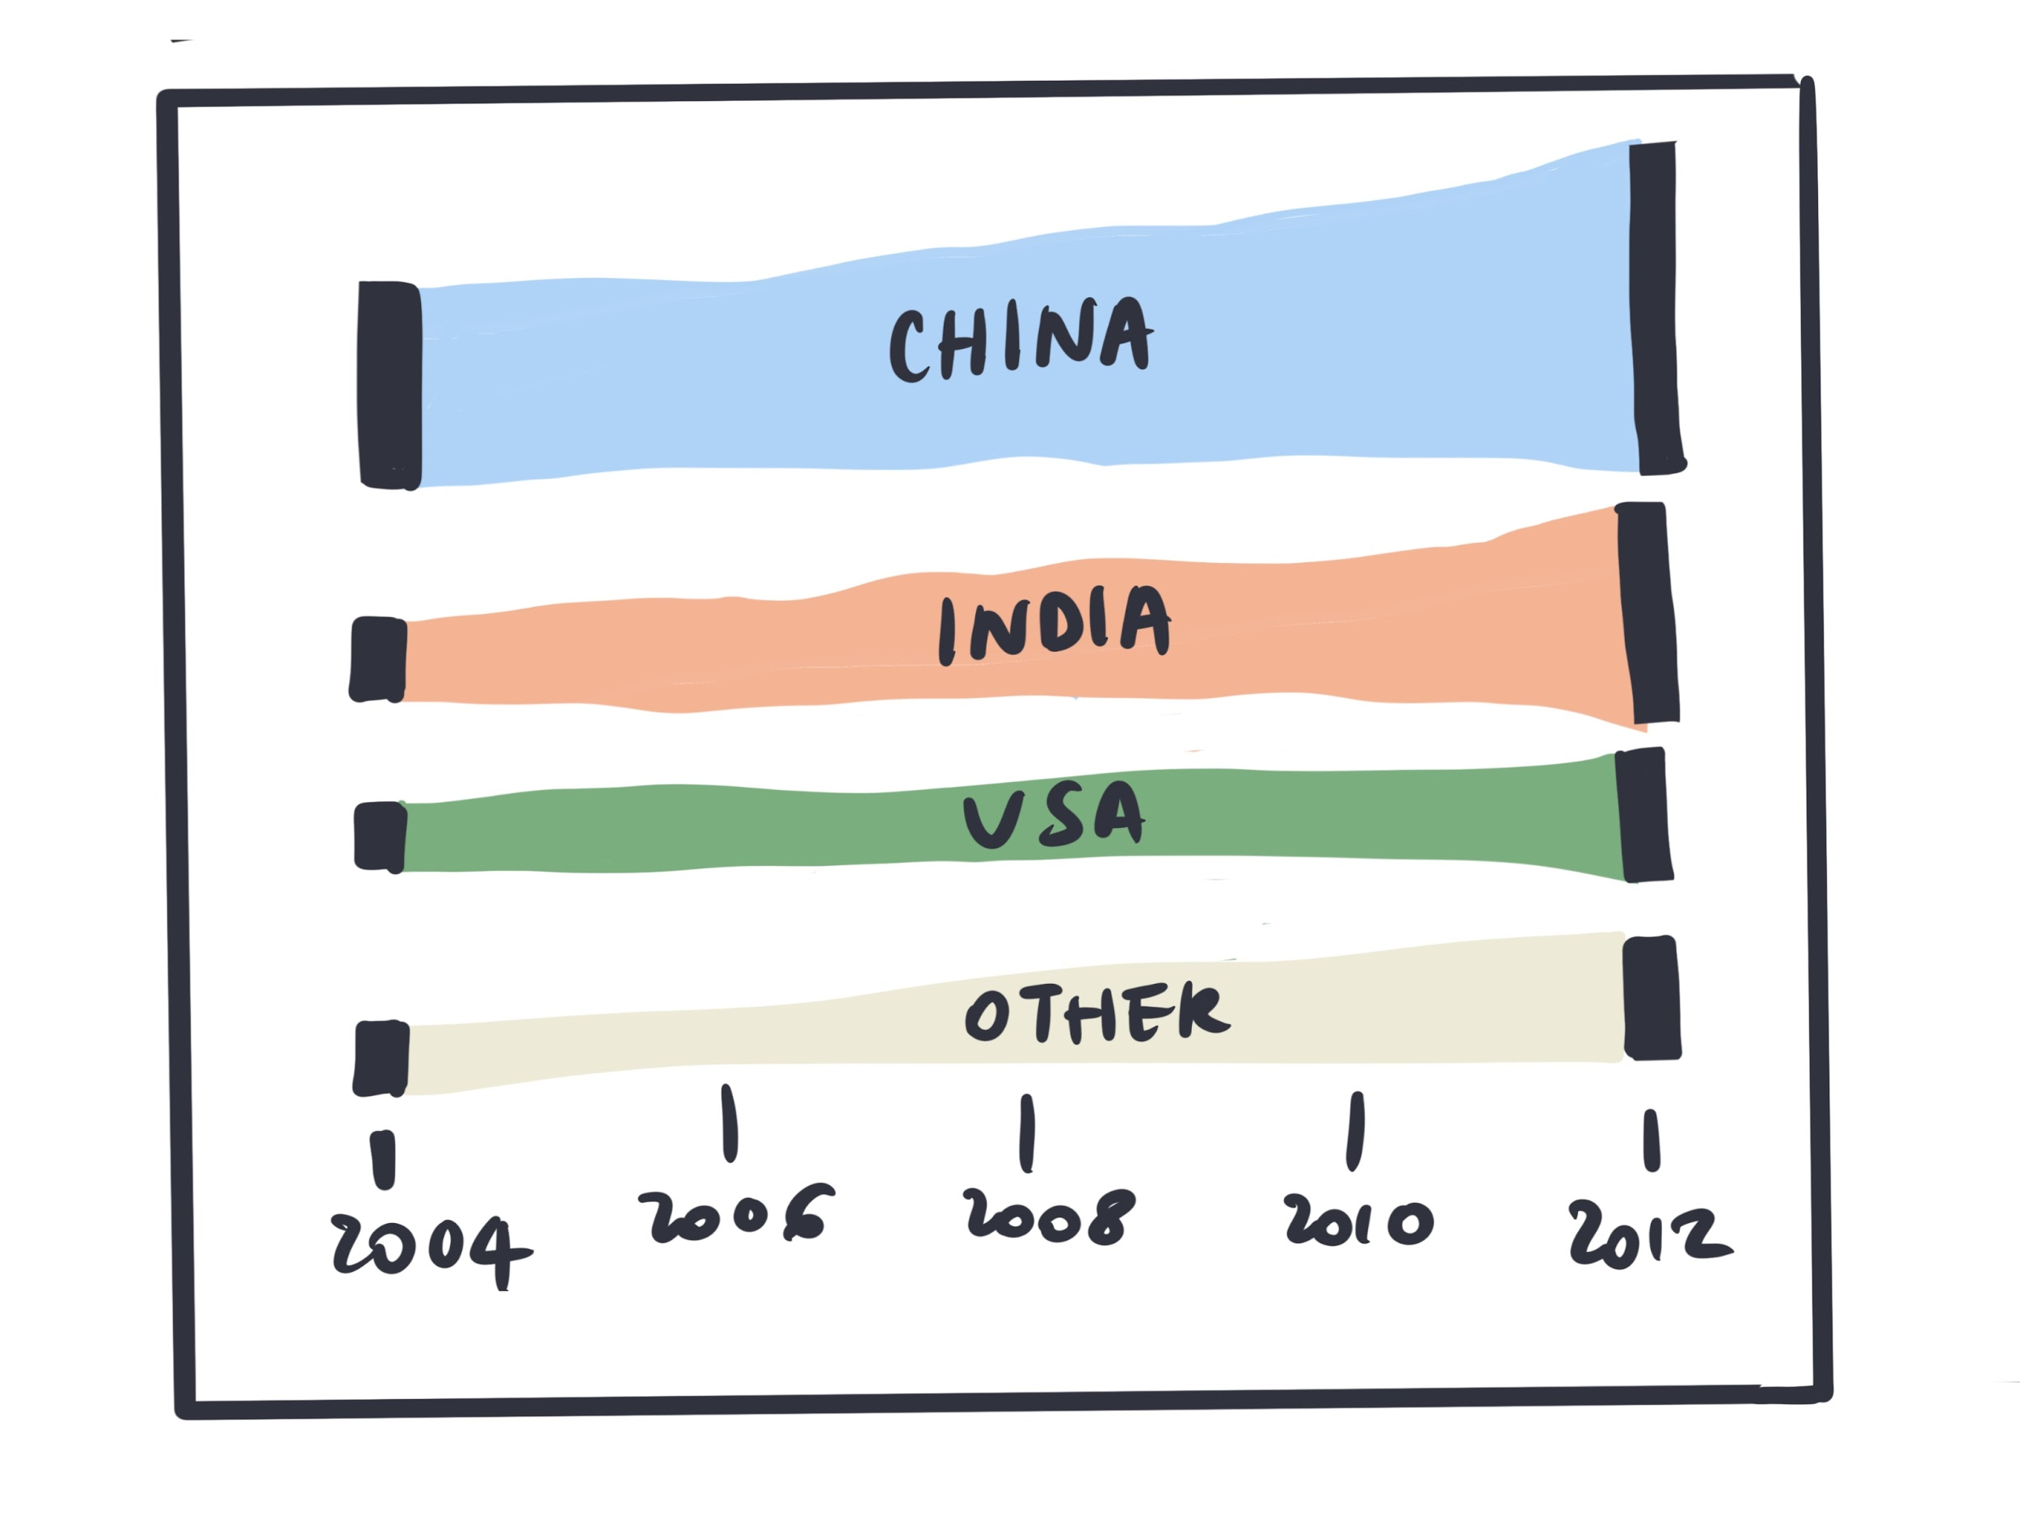

Figure 12: Another way to communicate previous findings

Figure 13: Combining different findings 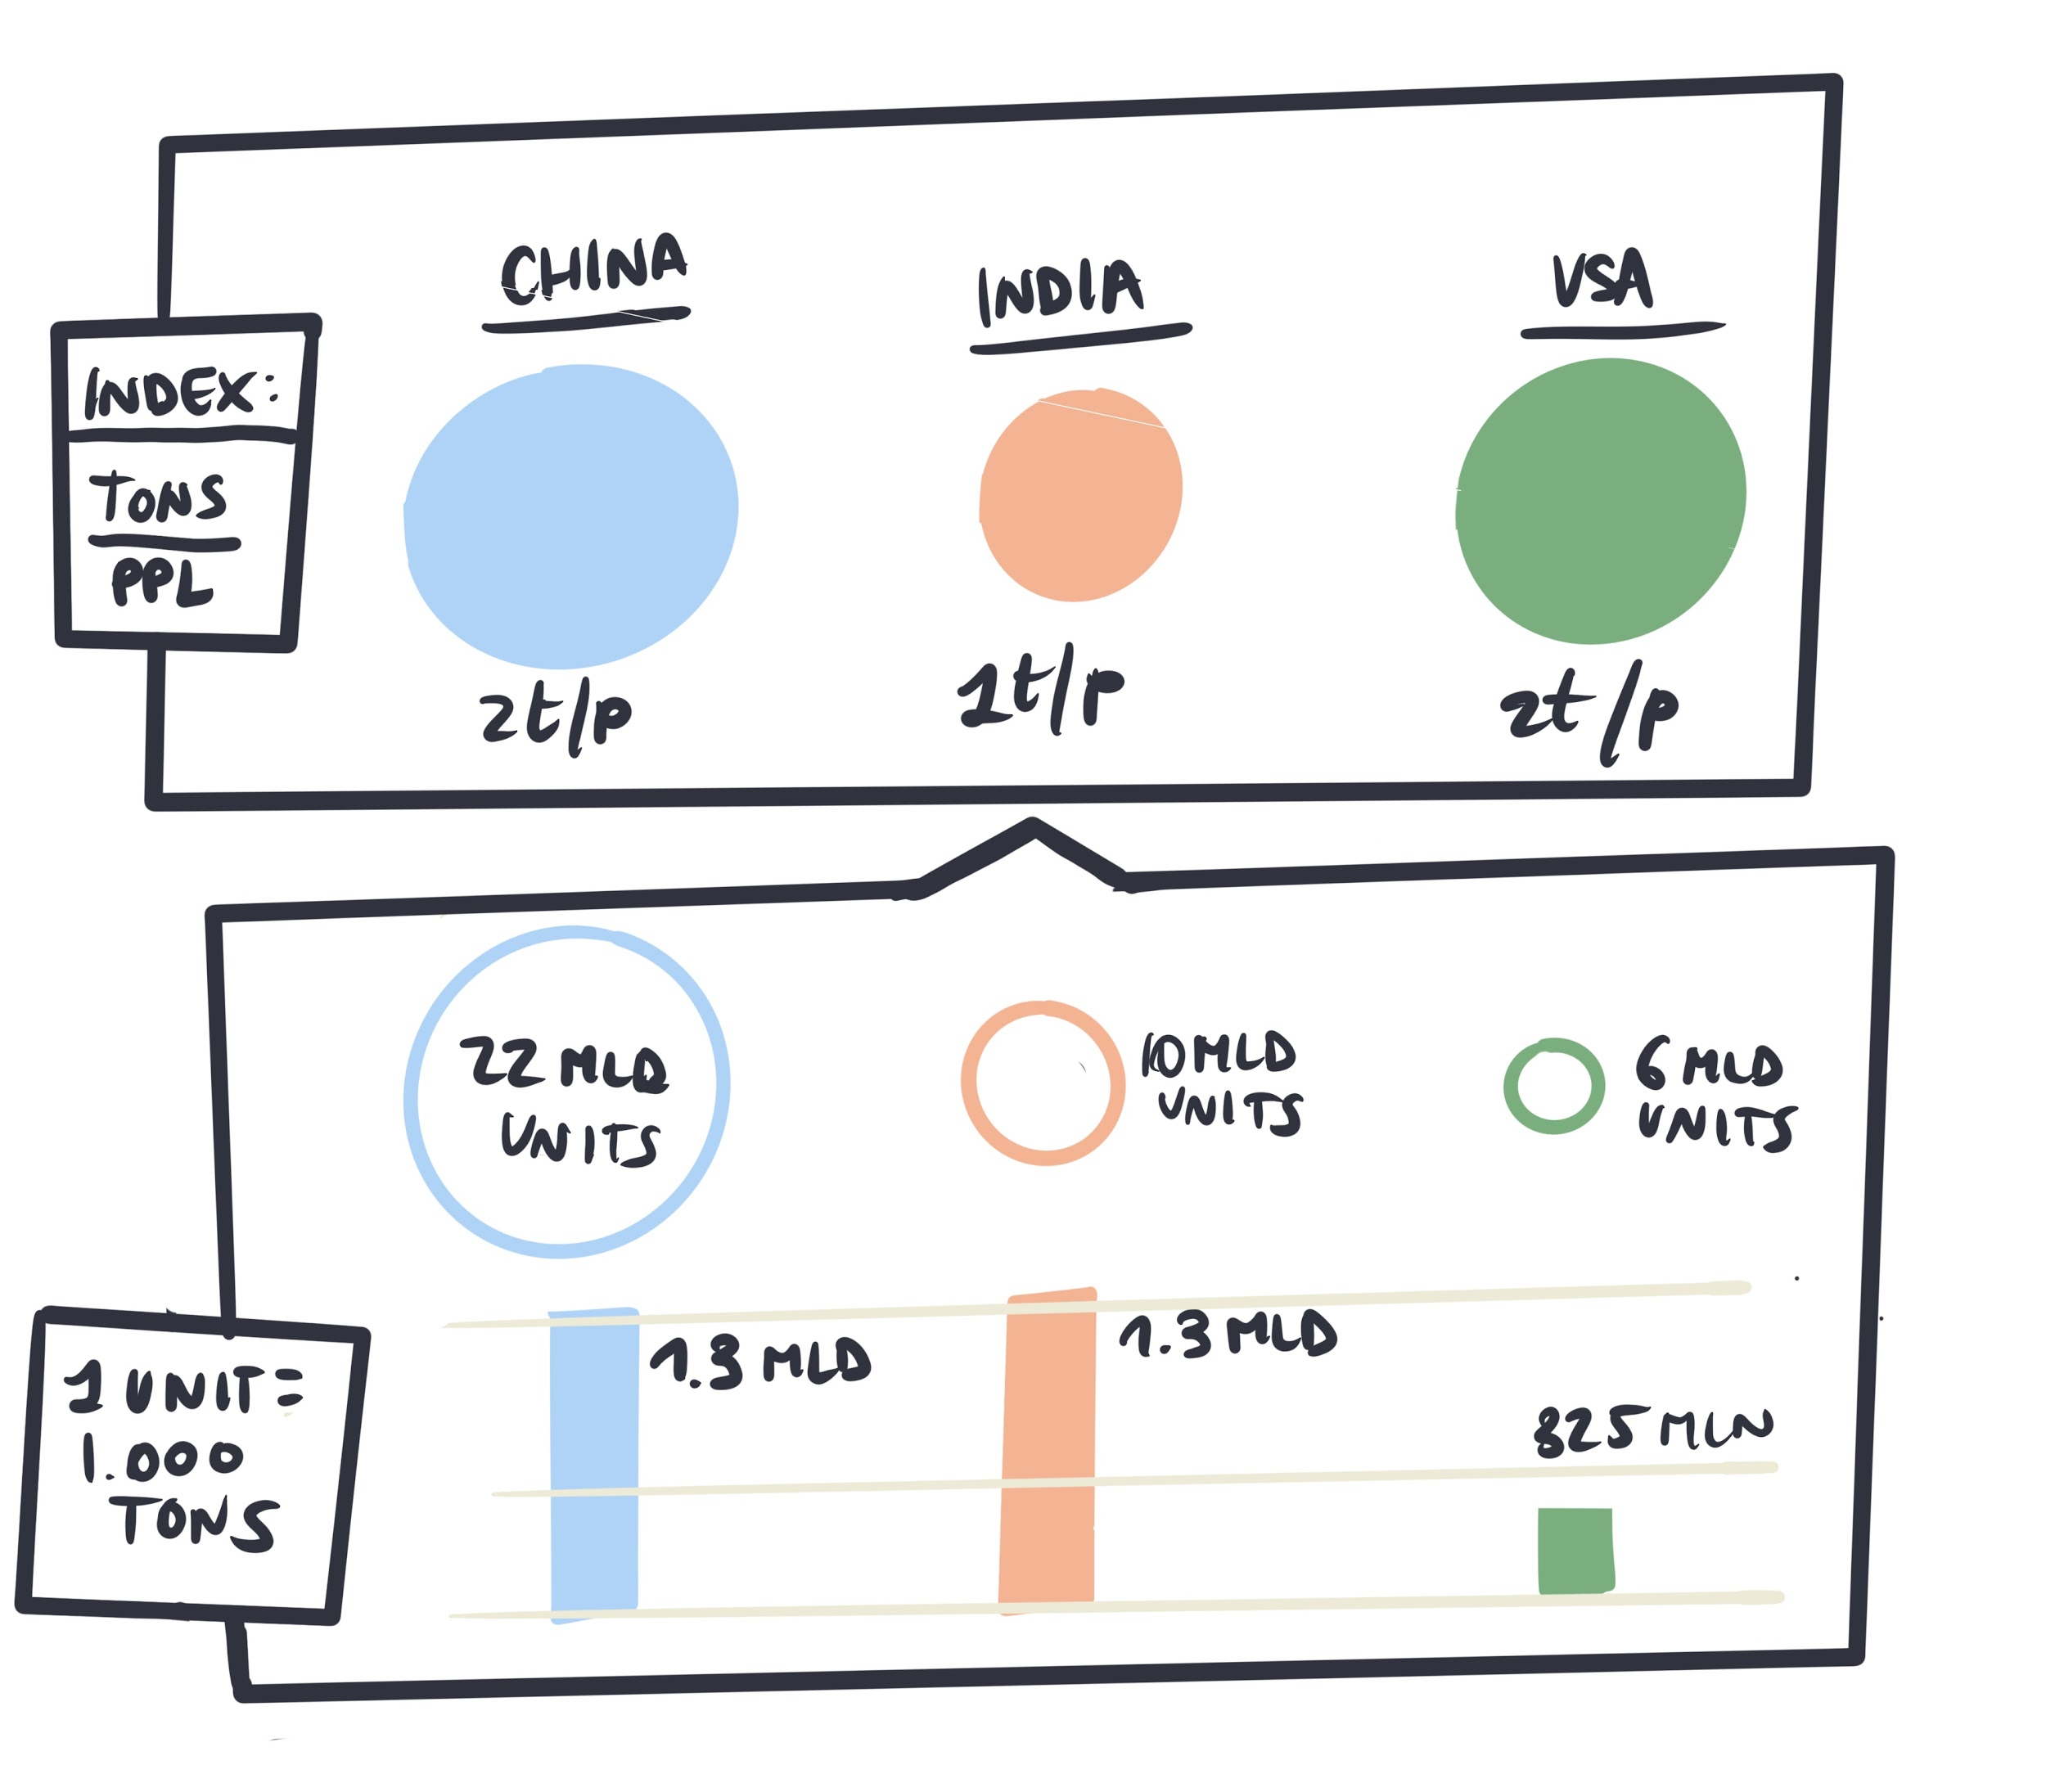

into a visual dashboard

## 03 /

# Crafting information

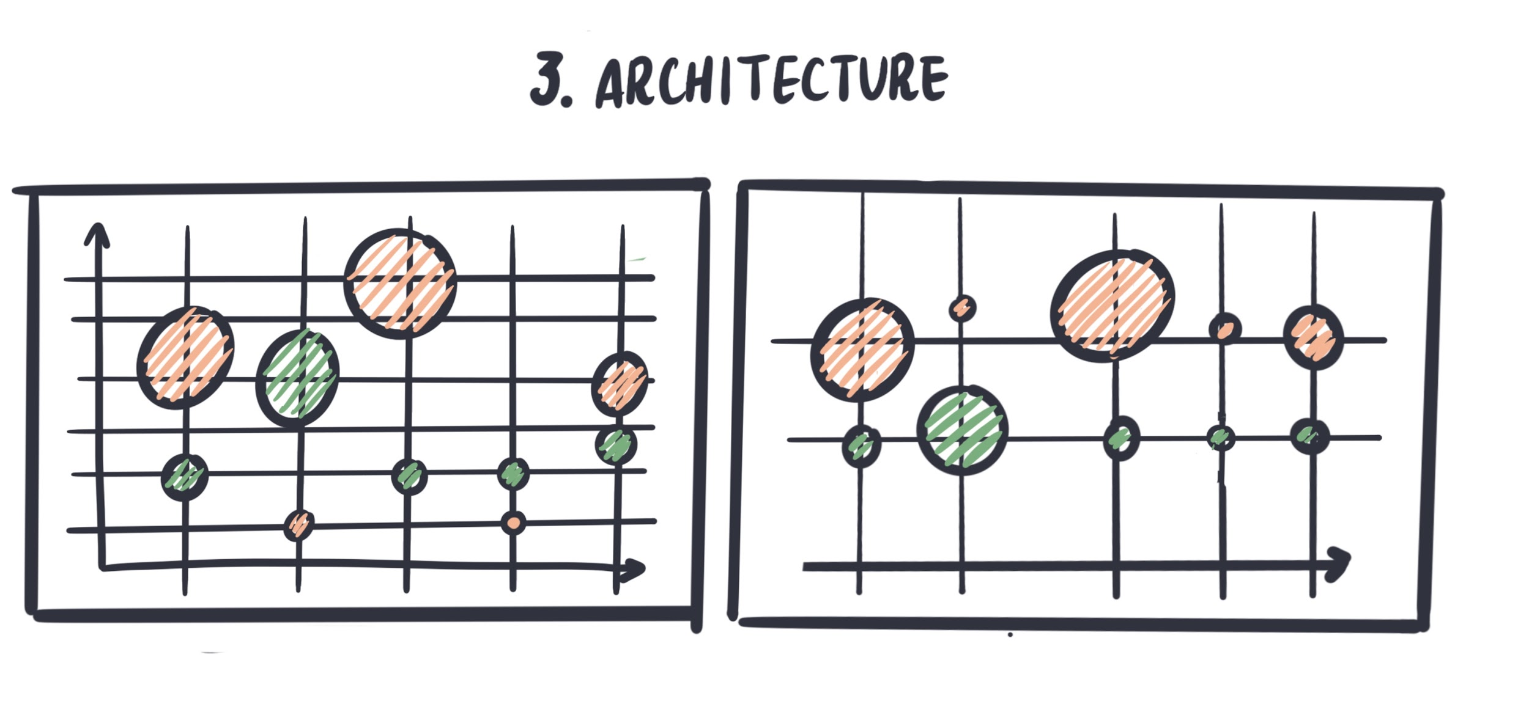

Figure 14: Architecture

Once you have all your sketches, you can start combining them to create the visual layout (or visual dashboard). Visual layouts communicate the story behind data taking different features and drawing correlations. There are some general guidelines to keep in mind, even though you can be creative with the customization of the visual variables. Be careful to maintain *visual consistency* between the visualizations! Don’t use too many elements - use always the same shapes to represent the same type of information. Define a limited color palette, respect the balance between the data and visual variables.

“Above all else show the data”

### 

### Exercise 3

**OUTLINE THE VISUALIZATION**

Make a list of data and visual variables

List the data variables that you would like to present and think about the visual variables that you might want to use. In general, these should be coordinated and well-balanced. This step helps in structuring the work and in deciding what are the pillars of your final visualization.

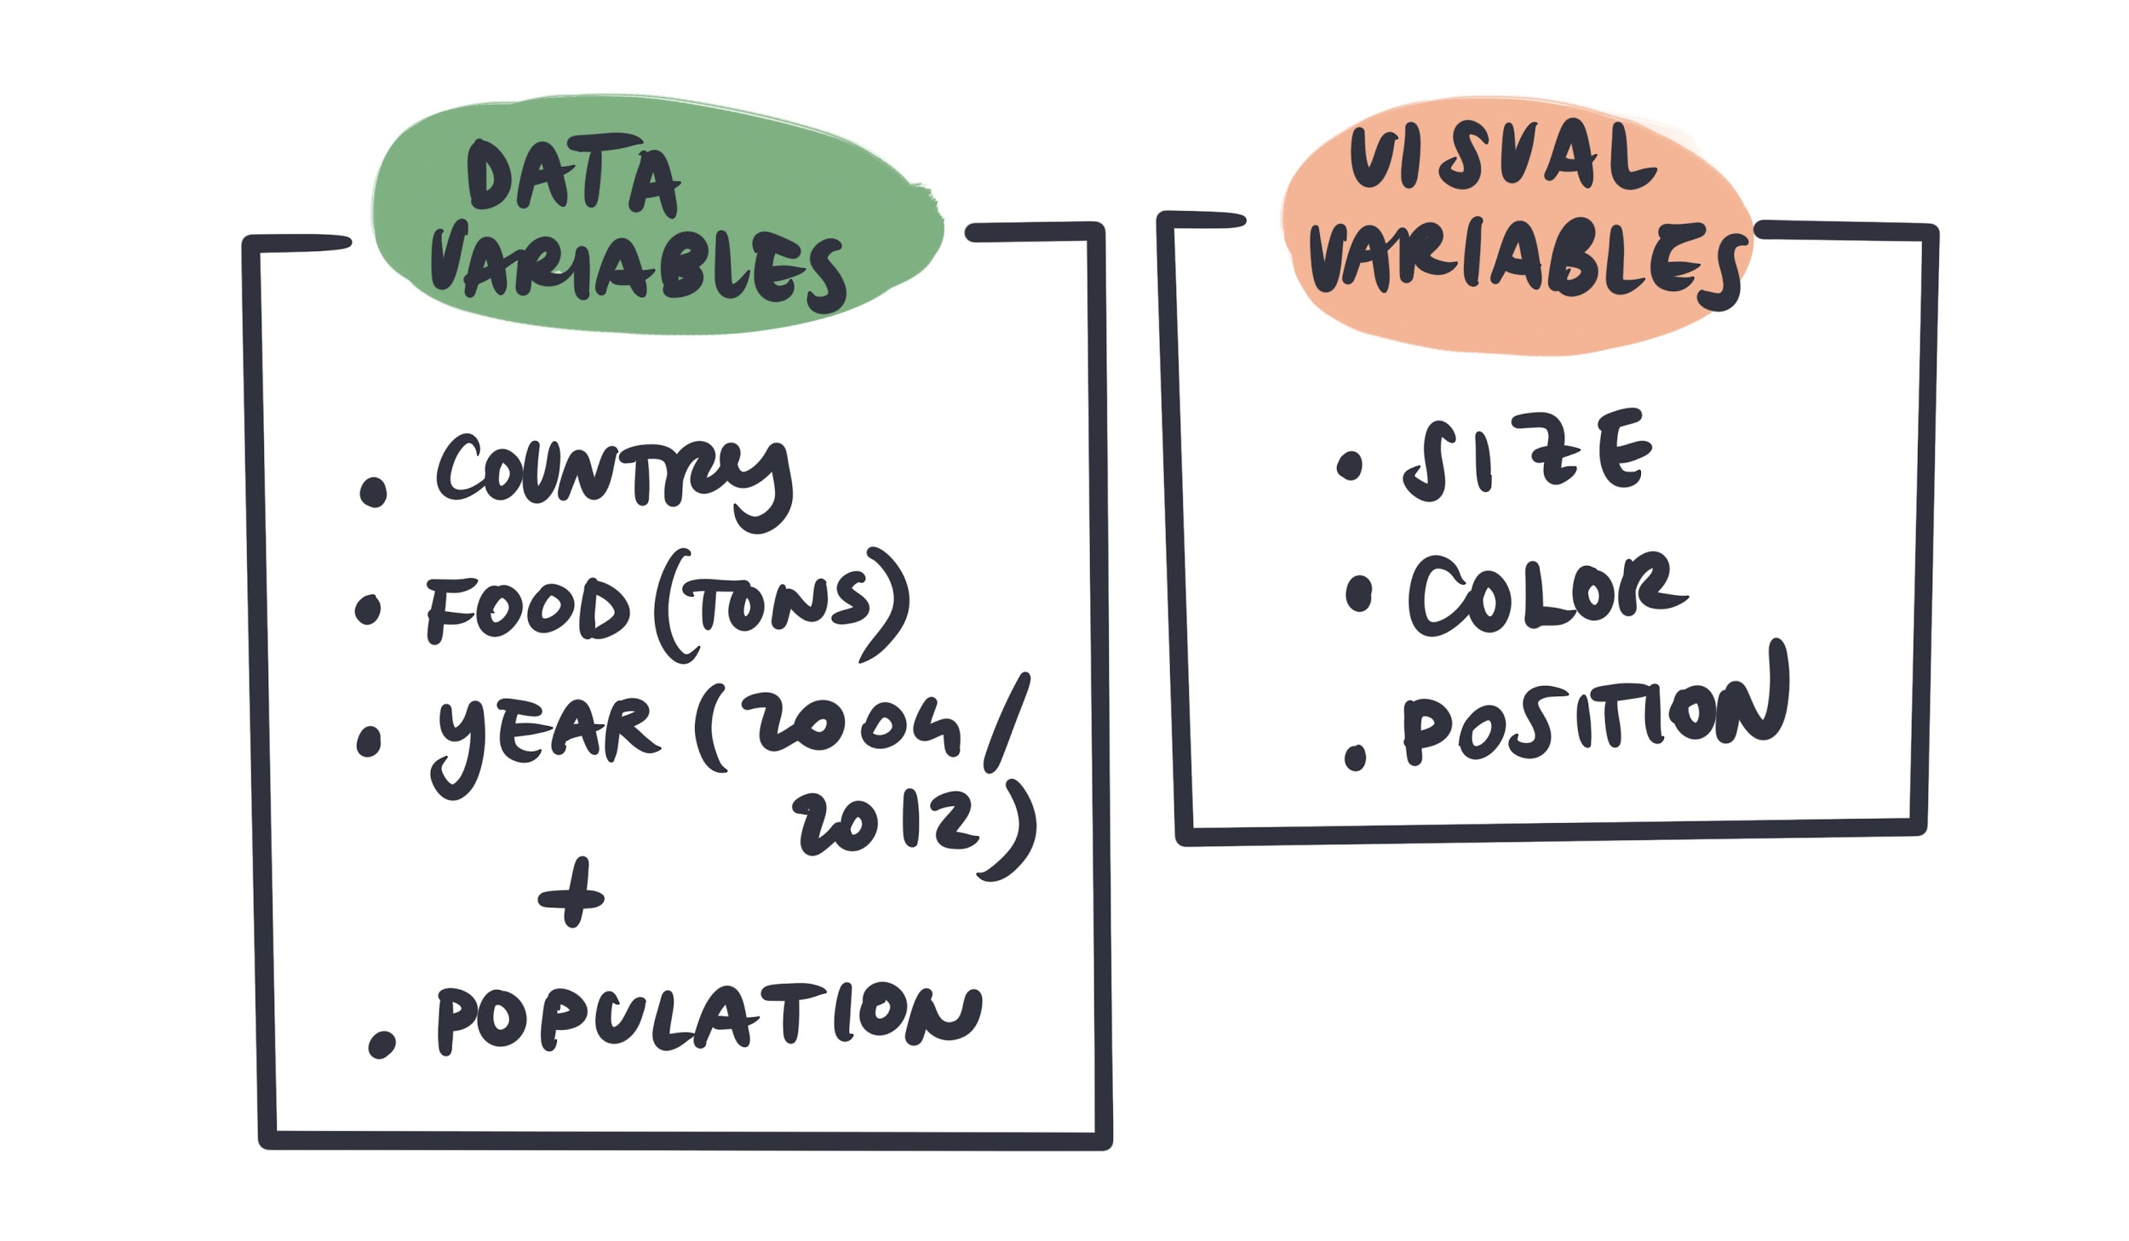

Figure 15: Data variables vs. Visual variables

*Create a single hand drawn visualisation*

##### 

##### Explore different combination of visual variables, draw them, and test the most effective ones. Once you have mapped out all of the visual concepts that you would like to visualize, choose a few that tell a good story. Create single hand draw visuals that show relationships between variables.

*You can fast sketch different shapes before choosing the best visualization to go with.*

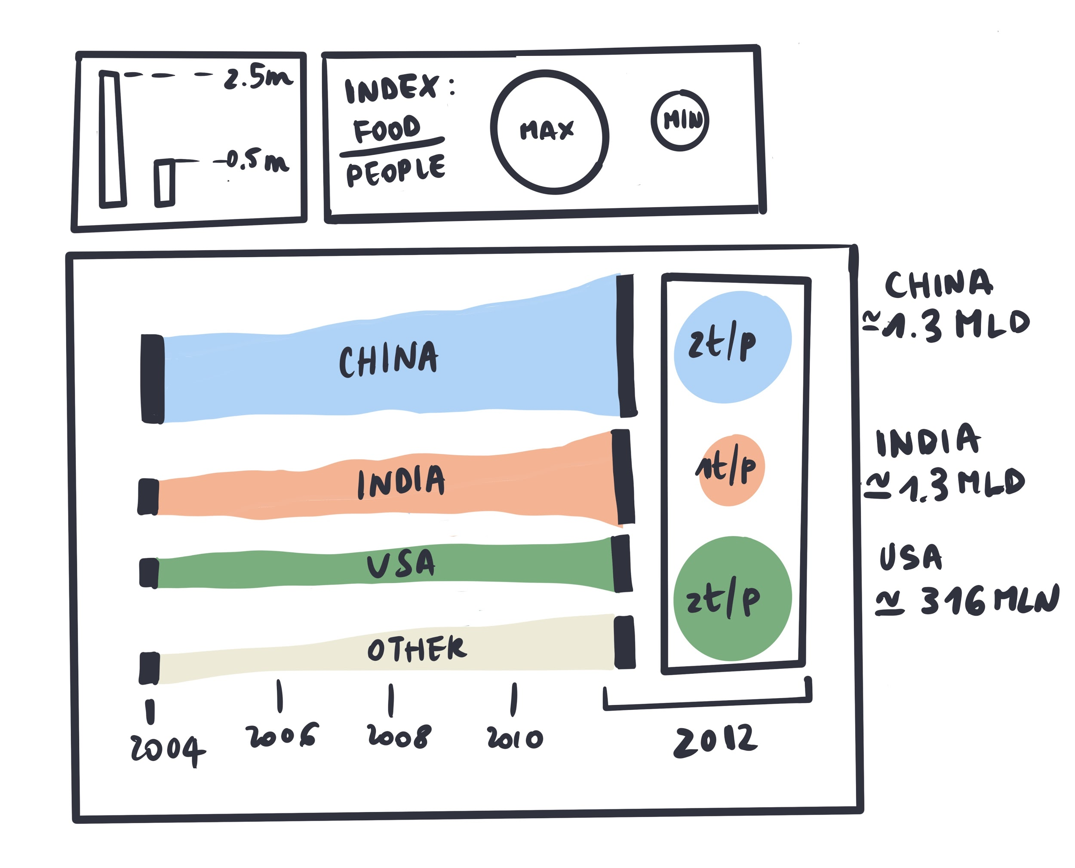

Figure 16: Looking for meaningful visual representations and

combining them into a final visual dashboard

## 04 /

# The visualization draft

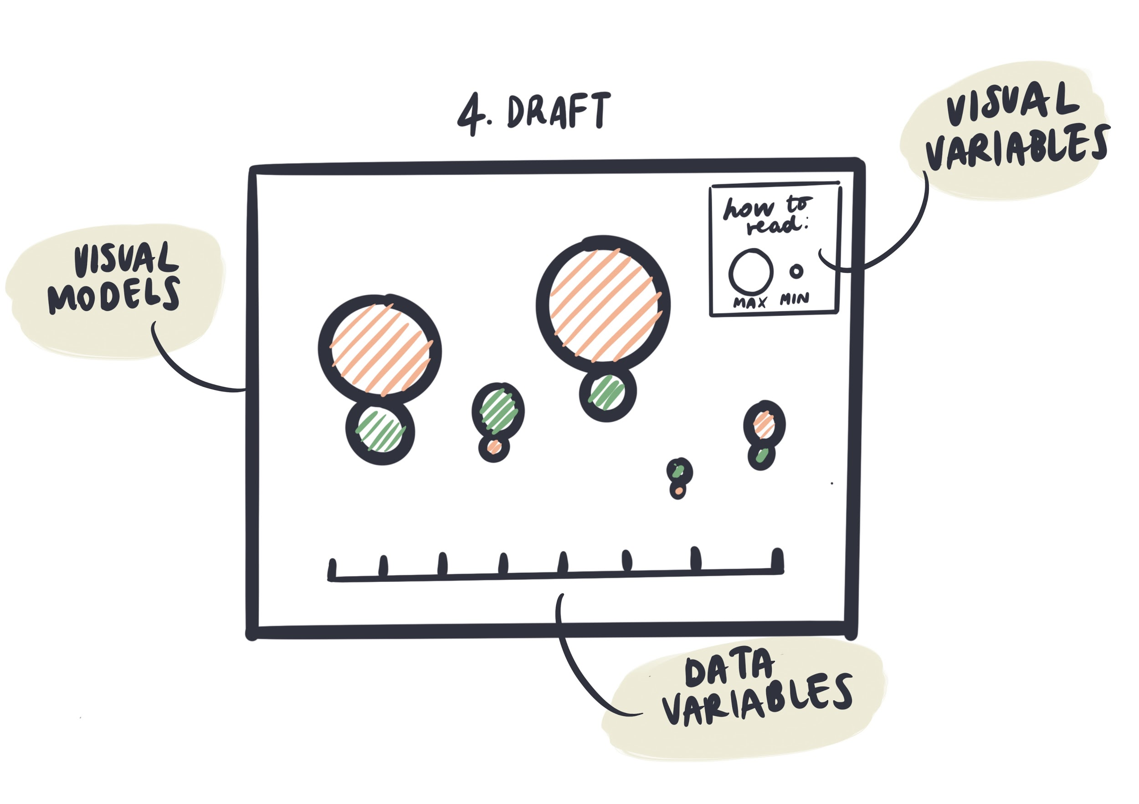

Figure 17: Communicate data and variables effectively

Editing and refining is very important step towards effective and meaningful visualizations. It is not trivial as is looks like - with a few iterations, constant changes, and new trials you will be able to conclude the communicative power of your visual choices. Moreover, it is always recommended to gather some feedbacks on your work, showing your creations to people outside of your domain.

### Exercise 3

**REFINE THE DRAWING**

*Edit and refine*

Edit and refine the visualization. Come up with a final draft, a visualization ready for a further implementation. Choose one final visualization architecture, outline the general layout, review and select the elements of your visuals. During this process keep asking yourself: *Does my work communicate my idea?*

# Credits and Additional Resources

01.

###### Invest in sketching

Ferdio Notebook

*“Sketching cannot be underestimated. It’s an essential part of the process‚ in which complex information is turned into clear visual ideas in rough, sketchy drawings. In many of our projects sketching actually ends up being the most time-consuming process – even more than design and production. But once the sketch is solved, designing and producing are the easy part.”*

Url: [here](https://www.ferdio.com/notebook/invest-in-sketching)

02.

###### A quick beginner’s guide to drawing

##### 6 drawing exercises to get you started right now!

by Ralph Ammer

Url: [here](https://medium.com/personal-growth/a-quick-beginners-guide-to-drawing-58213877715e)

03.

###### Drawing and Data Visualizations

A Tool To Allow Connections To Be Made

by Giorgia Lupi - Tableau Public Blog

Url: [here](https://public.tableau.com/en-us/s/blog/2014/11/drawing-and-data-visualizations-tool-allow-connections-be-made)

04.

###### Data Visualization through drawing and visual thinking

##### by Catherine Madden from FiftyThree

Youtube Channel Skillshare, 2018

Url: [here](https://www.youtube.com/watch?v=rZikhQ5w5Ck)

1. Edward_Tufte, a pioneer in the field of data visualization

   source: [here](https://en.wikipedia.org/wiki/Edward_Tufte)